NAME:J.VIVEK DSA0602-Data Handling and
REG NO:192325149 Visualization

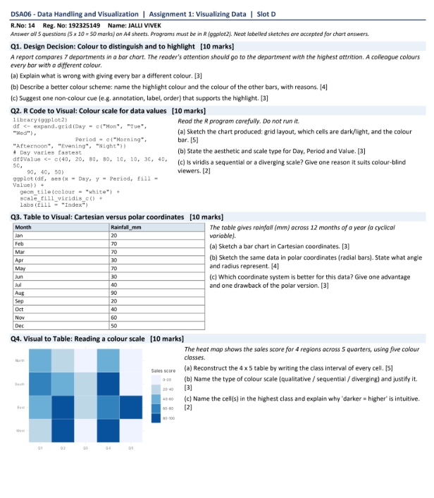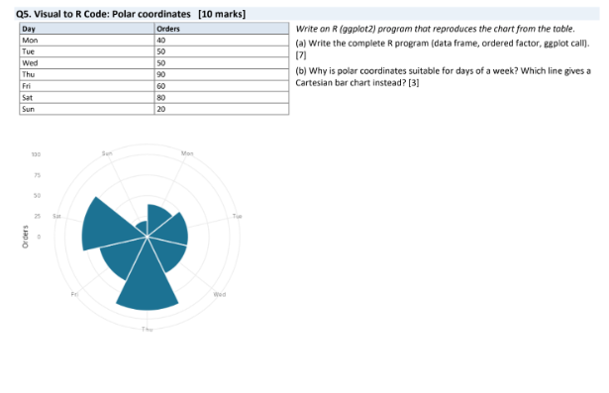
Q1. Design Decision: Colour to Distinguish and to Highlight
Question
A report compares 7 departments in a bar chart. The reader's attention should go to the department with the highest attrition. A colleague colours every bar with a different colour.
(a) Explain what is wrong with giving every bar a different colour.
Giving every bar a different colour is not a good design choice when the main purpose of the chart is to highlight the department with the highest attrition.
Firstly, using seven different colours creates unnecessary visual complexity. The reader may focus on the colours rather than the actual values represented by the bars.
Secondly, if every bar has a different colour, there is no visual hierarchy. All departments appear equally important even though the purpose of the chart is to draw attention to one particular department.
Thirdly, using many colours can make the chart difficult to interpret, especially for people with colour-vision deficiencies. Some colours may look very similar to colour-blind viewers.
Therefore, different colours should not be used merely for decoration. Colour should be used when it communicates meaningful information.
Main problems:
- It creates unnecessary visual clutter.
- It does not clearly highlight the department with the highest attrition.
- It can reduce accessibility and make comparison difficult.

(b) Describe a better colour scheme.
A better colour scheme would use one strong highlight colour for the department with the highest attrition and a neutral colour for all other departments.
For example:
- Department with highest attrition → dark red
- All other departments → light grey
The dark red colour immediately attracts the reader's attention because it has strong contrast against the grey bars.
The other departments should be kept in light grey because they are still important for comparison, but they should not compete visually with the highlighted department.
For example, if Department C has the highest attrition:
Department | Colour
Department A | Light grey
Department B | Light grey
Department C | Dark red
Department D | Light grey
Department E | Light grey
Department F | Light grey
Department G | Light grey

This colour scheme creates a clear visual hierarchy. The reader can immediately identify Department C as the department requiring attention.
The important principle is:
Use colour to communicate meaning, not simply to decorate the chart.

(c) Suggest one non-colour cue that supports the highlight.
One useful non-colour cue is a data label or annotation.
For example, above the highest bar we can write:
Highest Attrition – 28%
This provides the same information even if the reader cannot distinguish the highlight colour.
Another possibility is to place the highest department at the top of a sorted bar chart.
For example:
Department C ███████████████████ 28% ← Highest
Department A ██████████████ 20%
Department D ███████████ 17%
Department B █████████ 15%
...
The annotation or ordering makes the important value clear without depending only on colour.

Q2. R Code to Visual: Colour Scale for Data Values
The given R program creates a heatmap using ggplot2.
The data contains:
- 3 Days: Mon, Tue, Wed
- 4 Periods: Morning, Afternoon, Evening, Night
- 12 values
The values are:
40, 20, 80, 80,
10, 10, 30, 40,
50, 90, 40, 50
The important parts of the R code are:
ggplot(df, aes(x = Day, y = Period, fill = Value)) +
geom_tile(colour = "white") +
scale_fill_viridis_c() +
labs(fill = "Index")
(a) Sketch/describe the chart produced.
The chart produced is a heatmap.
A heatmap represents numerical values using different levels of colour intensity.
There are three columns representing the days:
Mon Tue Wed
There are four rows representing the periods:
Morning
Afternoon
Evening
Night
The data can be arranged as follows:
Period | Mon | Tue | Wed
Morning | 40 | 10 | 50
Afternoon | 20 | 10 | 90
Evening | 80 | 30 | 40
Night | 80 | 40 | 50

The Viridis continuous colour scale is used.
Lower values receive lighter colours, while higher values receive darker/more intense colours.
Therefore:
- Tue Morning = 10 → very light
- Tue Afternoon = 10 → very light
- Mon Afternoon = 20 → light
- Tue Evening = 30 → relatively light
- Mon Morning = 40 → medium
- Tue Night = 40 → medium
- Wed Evening = 40 → medium
- Wed Morning = 50 → medium
- Wed Night = 50 → medium
- Mon Evening = 80 → dark
- Mon Night = 80 → dark
- Wed Afternoon = 90 → darkest
The highest value is:
Wed – Afternoon = 90
Therefore, this cell should appear as the darkest cell in the heatmap.
A simple representation is:
Day
Mon Tue Wed

Morning 40 10 50
Afternoon 20 10 90
Evening 80 30 40
Night 80 40 50
The cells have white borders because the code contains:
geom_tile(colour = "white")

(b) State the aesthetic and scale type for Day, Period and Value.
There are three important variables in the visualization.
1. Day
Day is mapped to the x-axis.
aes(x = Day)
It is a categorical variable containing:
Mon, Tue, Wed
Therefore:
- Aesthetic: Position on x-axis
- Scale: Discrete scale
2. Period
Period is mapped to the y-axis.
aes(y = Period)
It contains:
Morning, Afternoon, Evening, Night
Therefore:
- Aesthetic: Position on y-axis
- Scale: Discrete scale
3. Value
Value is mapped to fill.
aes(fill = Value)
It contains numerical values such as 10, 20, 40, 80 and 90.
Therefore:
- Aesthetic: Fill/colour
- Scale: Continuous scale
Summary
Variable | Aesthetic | Scale
Day | X-axis position | Discrete
Period | Y-axis position | Discrete
Value | Fill/colour | Continuous
(c) Is Viridis sequential or diverging? Give one reason it suits colour-blind viewers.
The Viridis scale used in the code is a sequential colour scale.
A sequential scale is appropriate when values go from low to high and there is no meaningful central midpoint.
For example:
Low value ───────────────→ High value
Light Dark
Viridis is also suitable for colour-blind viewers because it is designed to provide good perceptual separation between colours, including for common forms of colour-vision deficiency.
It also provides a smooth progression of colour intensity, making differences in numerical values easier to perceive.

Q3. Table to Visual: Cartesian versus Polar Coordinates
The table gives rainfall in millimetres for 12 months.
Month | Rainfall (mm)
Jan | 20
Feb | 70
Mar | 70
Apr | 30
May | 70
Jun | 30
Jul | 40
Aug | 90
Sep | 20
Oct | 40
Nov | 60
Dec | 50

(a) Sketch a bar chart in Cartesian coordinates.
A Cartesian bar chart has:
- X-axis: Month
- Y-axis: Rainfall in mm
The months are arranged from January to December.
The rainfall values determine the height of each bar.
Rainfall
100 |
90 | █
80 | █
70 | █ █ █ █
60 | █ █ █ █ █
50 | █ █ █ █ █ █
40 | █ █ █ █ █ █ █
30 | █ █ █ █ █ █ █ █
20 | █ █ █ █ █ █ █ █ █
10 | █ █ █ █ █ █ █ █ █
0 +------------------------------------------------
Jan Feb Mar Apr May Jun Jul Aug Sep Oct Nov Dec
The actual bar heights are:
Jan = 20
Feb = 70
Mar = 70
Apr = 30
May = 70
Jun = 30
Jul = 40
Aug = 90
Sep = 20
Oct = 40
Nov = 60
Dec = 50
The highest rainfall occurs in:
August = 90 mm
The lowest rainfall occurs in:
January and September = 20 mm
A Cartesian bar chart makes these comparisons straightforward because all bars share a common horizontal baseline.
b) Sketch the same data in polar coordinates. State what angle and radius represent.
A polar/radial bar chart represents the 12 months around a circle.
Since there are 12 months, the complete circle contains:
\[ 360^\circ \]
Therefore, the angle assigned to each month is:
\[ \frac{360^\circ}{12}=30^\circ \]
So:
Each month occupies 30°
More generally, each sector represents one month.
Meaning of angle
The angle identifies the month.
For example:
- January → 30° sector
- February → next 30° sector
- March → next 30° sector
- and so on.
Meaning of radius
The radius/bar length represents rainfall.
For example:
- January → radius = 20 mm
- February → radius = 70 mm
- March → radius = 70 mm
- August → radius = 90 mm
Therefore, August will have the longest radial bar.
The exact visual would contain radial bars extending outward according to rainfall.

(c) Which coordinate system is better? Give one advantage and one drawback of the polar version.
For this particular data, Cartesian coordinates are better for accurate comparison.
Advantage of Cartesian coordinates
Cartesian bar charts provide a common baseline, making it easy to compare rainfall between months.
For example, it is immediately clear that:
August = 90 mm
February = 70 mm
March = 70 mm
The differences can be judged accurately.
Advantage of polar coordinates
Polar coordinates are useful because the months form a cycle. December naturally connects back to January, so the circular layout represents the yearly cycle effectively.
Drawback of polar coordinates
The main disadvantage is that comparing radial lengths is more difficult than comparing vertical bar heights.
For example, comparing:
February = 70 mm
March = 70 mm
May = 70 mm
is less precise in a circular chart than in a standard Cartesian chart.
Also, bars near different angles can be harder to compare visually because the eye does not have the same straight baseline.

Q4. Visual to Table: Reading a Colour Scale
The heatmap shows sales scores for 4 regions across 5 quarters.
The colour legend has five classes:
- 0–20
- 20–40
- 40–60
- 60–80
- 80–100
The colour becomes darker as the sales score increases.

(a) Reconstruct the 4 × 5 table.
We examine each cell of the heatmap and match its colour with the legend.
The reconstructed table is:
Region | Q1 | Q2 | Q3 | Q4 | Q5
North | 60–80 | 20–40 | 0–20 | 60–80 | 0–20
South | 60–80 | 40–60 | 20–40 | 80–100 | 0–20
East | 60–80 | 80–100 | 20–40 | 60–80 | 80–100
West | 20–40 | 80–100 | 0–20 | 80–100 | 0–20
Explanation
North
- Q1 → 60–80
- Q2 → 20–40
- Q3 → 0–20
- Q4 → 60–80
- Q5 → 0–20
South
- Q1 → 60–80
- Q2 → 40–60
- Q3 → 20–40
- Q4 → 80–100
- Q5 → 0–20
East
- Q1 → 60–80
- Q2 → 80–100
- Q3 → 20–40
- Q4 → 60–80
- Q5 → 80–100
West
- Q1 → 20–40
- Q2 → 80–100
- Q3 → 0–20
- Q4 → 80–100
- Q5 → 0–20
Therefore, the completed table is:
Q1 Q2 Q3 Q4 Q5
North 60-80 20-40 0-20 60-80 0-20
South 60-80 40-60 20-40 80-100 0-20
East 60-80 80-100 20-40 60-80 80-100
West 20-40 80-100 0-20 80-100 0-20
(b) Name the type of colour scale and justify it.
The heatmap uses a sequential colour scale.
A sequential colour scale represents values that move continuously or progressively from low to high.
In this heatmap:
0–20 → Lightest
20–40 → Light
40–60 → Medium
60–80 → Dark
80–100 → Darkest
The colours have a natural ordering from low sales scores to high sales scores.
It is not a diverging scale because there is no important central value around which the colours diverge.
For example, if the meaningful midpoint were 50, a diverging scale could have one colour for low values, another for values near 50, and a different colour for high values.
Here, however, the main purpose is simply:
Low sales → High sales
Therefore, a sequential colour scale is appropriate.

(c) Name the cells in the highest class and explain why "darker = higher" is intuitive.
The highest class is:
80–100
From the heatmap, the cells belonging to this class are:
- South – Q4
- East – Q2
- East – Q5
- West – Q2
- West – Q4
These cells use the darkest colour.
Why is "darker = higher" intuitive?
A darker or more intense colour naturally attracts more visual attention than a lighter colour. Therefore, assigning darker colours to larger values creates a simple visual relationship:
More intensity → More quantity
This makes it easier for the reader to quickly identify areas with higher sales scores.

Q5. Visual to R Code: Polar Coordinates
The given table contains the number of orders received on each day of a week.
Day | Orders
Mon | 40
Tue | 50
Wed | 50
Thu | 90
Fri | 60
Sat | 80
Sun | 20
a) Write the complete R program.
The following R program creates the chart using ggplot2.
library(ggplot2)
# Create the data frame
df <- data.frame(
Day = c("Mon", "Tue", "Wed", "Thu", "Fri", "Sat", "Sun"),
Orders = c(40, 50, 50, 90, 60, 80, 20)
)
# Arrange days in correct weekly order
df$Day <- factor(
df$Day,
levels = c("Mon", "Tue", "Wed", "Thu", "Fri", "Sat", "Sun")
)
# Create polar bar chart
ggplot(df, aes(x = Day, y = Orders)) +
geom_col(fill = "steelblue", width = 1) +
coord_polar() +
labs(
x = NULL,
y = "Orders"
) +
theme_minimal()
Explanation of the R program
Step 1: Load ggplot2
library(ggplot2)
The ggplot2 library is used to create the visualization.
Step 2: Create the data frame
df <- data.frame(
Day = c("Mon", "Tue", "Wed", "Thu", "Fri", "Sat", "Sun"),
Orders = c(40, 50, 50, 90, 60, 80, 20)
)
This creates a data frame containing two columns:
- Day
- Orders
The values are:
Monday 40
Tuesday 50
Wednesday 50
Thursday 90
Friday 60
Saturday 80
Sunday 20
Step 3: Set the order of days
df$Day <- factor(
df$Day,
levels = c("Mon", "Tue", "Wed", "Thu", "Fri", "Sat", "Sun")
)
This ensures that the days appear in the correct order.
Without explicitly setting factor levels, categorical data may sometimes be displayed in alphabetical order.
Step 4: Create the bar chart
ggplot(df, aes(x = Day, y = Orders))
Here:
- Day is mapped to the x-axis.
- Orders is mapped to the y-axis.
Step 5: Create bars
geom_col(fill = "steelblue", width = 1)
geom_col() creates bars whose heights are directly determined by the values in Orders.
Step 6: Convert to polar coordinates
coord_polar()
This is the most important line.
It converts the normal Cartesian bar chart into a circular/polar bar chart.
Without this line, the result would be a normal vertical bar chart.
Step 7: Add labels
labs(
x = NULL,
y = "Orders"
)
This removes the x-axis title and labels the radial scale as Orders.
Step 8: Apply a clean theme
theme_minimal()
This gives the chart a simple and clean appearance.

(b) Why are polar coordinates suitable for days of a week? Which line gives a Cartesian bar chart instead?
Polar coordinates are suitable for days of the week because a week is a cyclical variable.
The sequence is:
Monday → Tuesday → Wednesday → Thursday
→ Friday → Saturday → Sunday
→ Monday
After Sunday, the cycle starts again with Monday.
A circular visualization represents this cyclical relationship naturally because the end and beginning of the week are visually connected.
The radial chart also allows us to compare the number of orders across the days.
From the data:
- Monday = 40
- Tuesday = 50
- Wednesday = 50
- Thursday = 90
- Friday = 60
- Saturday = 80
- Sunday = 20
The highest number of orders is:
Thursday = 90 orders
The lowest number of orders is:
Sunday = 20 orders
Therefore, the Thursday bar should extend the furthest from the centre, while Sunday should be the shortest.
Which line gives a Cartesian bar chart?
The line:
coord_polar()
converts the Cartesian bar chart into a polar chart.
Therefore, if we remove:
coord_polar()
the result becomes a normal Cartesian bar chart.
For example:
ggplot(df, aes(x = Day, y = Orders)) +
geom_col(fill = "steelblue", width = 1) +
labs(
x = "Day",
y = "Orders"
) +
theme_minimal()
This produces a standard vertical bar chart.

